The model trained here is a CoAtNet + Self-Attention Classifier, designed to classify individual keystrokes from recorded keyboard audio. Each keystroke is converted into a log-mel spectrogram, allowing the model to learn spectral and temporal features associated with different keys. The classifier predicts 27 classes (letters a-z and the space key). We are trying to demonstrate how the model behaves against gradient based attacks (FGSM, BIM and PGD) and DFT-based frequency perturbation attacks on test dataset, these attacks act as noise and highlight how models could be tricked to misclassify by addition of noise.
The architecture combines convolution layers for “local feature extraction” with self-attention layers that capture “long-range dependencies” in spectrogram frames. This hybrid structure improves classification accuracy by allowing the model to learn subtle acoustic differences between keystrokes.
To evaluate robustness, the above stated attacks are performed. Gradient based attacks modify the input spectrogram using the gradient of the loss with respect to the input, while the DFT attack perturbs the signal in the frequency domain before reconstruction. Evaluation metrics used include clean accuracy, adversarial accuracy, and attack success rate (ASR) per keystroke class. An attack is considered successful when adversarial accuracy dropped below 60%.
Results show that the gradient-based attacks were significantly effective compared to DFT attacks. At higher perturbation strengths (epsilon = 0.05), FGSM, BIM and PGD consistently reduced adversarial accuracy below 60% across all keystrokes and with PGD for epsilon = 0.02, indicating complete attack success. Moderate perturbations (epsilon = 0.02) produced partial success, affecting some keys. The DFT attack, on the other hand, did not successfully compromise the classifier, with adversarial accuracy remained above 78% across all perturbation levels.
These show that even high-performing architectures can be vulnerable to adversarial manipulation if robustness is not explicitly incorporated during training. While the classifier performs well on clean data, but despite the advanced architecture, the CoAtNet Self Attention model remains vulnerable to gradient-based attacks for the following reasons:
- The model is fully differentiable, meaning gradients of the loss function with respect to the input can be computed. Gradient-based attacks exploit this property directly.
- The model was trained only on clean training data. Standard training optimizes accuracy but does not teach the model how to resist adversarial perturbations.
- And finally, log-mel spectrograms are sensitive to small changes in frequency energy. Even small perturbation can alter the spectral patterns used by the model for classification.
And as for DFT Attack, it doesn’t directly use the model’s gradients. Instead, it modifies frequency components in a general way. And since the perturbations are not aligned with the model’s decision boundary, they are less likely to produced targeted misclassifications. As a result, the attack tends to be weaker than gradient-based methods.
Future works could explore defense techniques such as adversarial training, input preprocessing, or randomized smoothing to improve the robustness of keystroke classification systems.
Here’s some of the output (overall across the lowest epsilon and then the point of successful gradient-based attacks):
Failed Attacks:
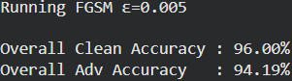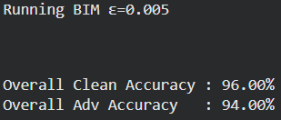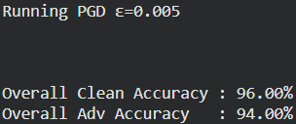
Success:
